

FURTHER MATHEMATICS
TRIAL EXAMINATION 1
2002
SOLUTIONS

_____________________________________________________________________

Section A Section B – answers
answers

Core Module 1 Module 2 Module 3 Module 4 Module 5

1. C Arithmetic Geometry Graphs Business Networks
2. B and and and related and
3. B applications trigonometry relations mathematics decision
4. D maths
5. B 1. E 1. E 1. B 1. C 1. C
6. C 2. C 2. C 2. A 2. D 2. C
7. E 3. D 3. B 3. D 3. A 3. E
8. A 4. A 4. B 4. E 4. E 4. D
9. A 5. B 5. C 5. C 5. D 5. B
10. A 6. E 6. B 6. D 6. C 6. A
11. D 7. C 7. D 7. B 7. B 7. A
12. A 8. D 8. C 8. A 8. D 8. A
13. D 9. B 9. D 9. C 9. D 9. E
___________________________________________________________________________

Section A: Core - solutions

Question 1
Using a graphics calculator enter all 18 scores. Note that the scores to be entered are
145, 148, 150, 151 and so on. In other words take the stem with the leaf!
The standard deviation is 11.78 (to 2 decimal places).
The answer is C.

Question 2
The interquartile range =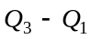. Now, 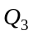 is the midpoint of the top half of the scores and 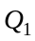 is the midpoint of the bottom half of the scores. There are 20 scores in the distribution. Now 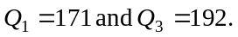 So 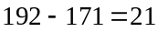.
The answer is B.

Question 3
In this group of Year 3 children, there are 3 students with a handspan of less than 170cm. There are 20 Year 3 children in the group.
So the percentage of Year 3 children with a handspan less than 170cm
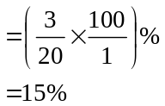
The answer is B.
Question 4
Comparing the distributions, we note that the distribution of the handspans of the Year 3 students is a little more variable (that is, the distribution is a little more spread out) than that of the Prep students. So option A is eliminated. Neither distribution has outliers so option B is eliminated. Neither distribution is skewed – both are reasonably symmetrical. This eliminates options C and E. The distribution of the handspans of Year 3 students does have a higher centre than that of the Prep students as you would expect since Year 3 students presumably have bigger hands.
The answer is D.

Question 5
The mean is 500g and the standard deviation is 15g. So, 470g is located 2 standard deviations below the mean.
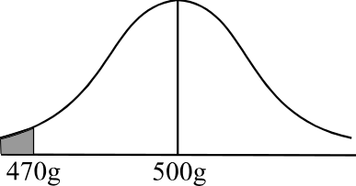
We know that 95% of the population
lies between 2 standard deviations of the mean.
so, 5% lies ‘outside’ 2 standard deviations of
the mean. Because of the symmetrical nature
of the bell-shaped curve, 2.5% lies above 2
standard deviations above the mean and
2.5% lies below 2 standard deviations
below the mean.
The answer is B.

Question 6
Using the equation
we have, when the number of tracks is 30,
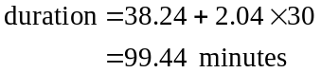
The answer is C.

Question 7
For the least squares regression line given by ,
the 2.04 represents the average duration of 1 track since for every increase of 1 track in the number of tracks on the cd, the duration of the cd increases by 2.04.
The answer is E.

Question 8
The residual plot shows the vertical distance between the actual point on the scatterplot and the point predicted by the least squares regression line.
For the point 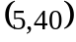 we have
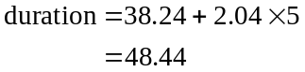
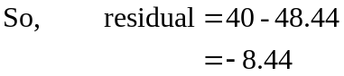
This eliminates options B and C.
For the point 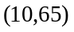, we have
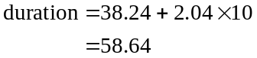
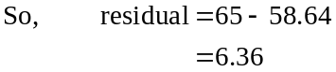
This eliminates option E.
Continue this process for all the points or, more quickly, just look at the vertical distance between the actual point and the corresponding point on the line. Note that the residual for the point (20, 70) is incorrect for option D. The correct option is A.
The answer is A.

Question 9
First divide the points into 3 groups with roughly the same number in each with the same number in the outside groups, if possible.

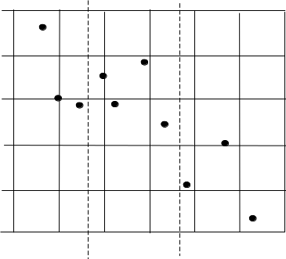

Work out the median in each of the three groups.
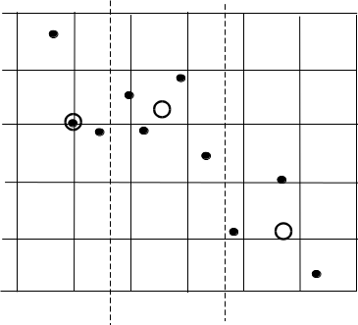

Draw a line through the two outside medians.

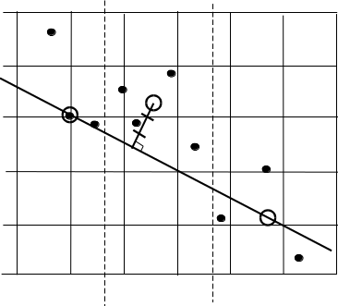

Move this line one third of the way towards the median of the centre group of data.
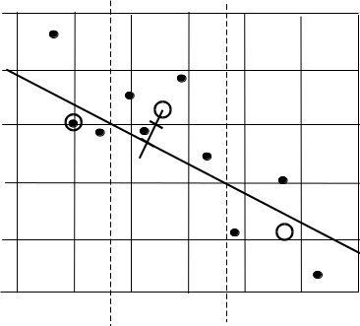

This is the 3 median line.
The answer is A.

Question 10

A 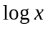 transformation compresses the X-scale. A 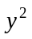 transformation expands the Y-scale.
Note that option B is nonsensical since the data is already linear in form and hence does not require any transformation. Option C is suited to a transformation to compress the X-scale but is not suited to having the y-scale expanded.
Option D needs the X-scale expanded or the Y-scale compressed.
Option E needs the X-scale expanded.
Option A is the only possibility.
The answer is A.

Question 11

There appears to be a cyclic trend with a cycle lasting about 2 years. Note that this cannot be seasonal variation since seasonal variations occur within a time span of one year of less. That is, if the number of visitors is low one summer then it is low the next summer and so on. There is no general trend upwards.
The answer is D.

Question 12

The four seasonal indices must add to give 4. The two seasonal indices given add up to 2.15. The only thing we require then is that the 2 numbers given add to give 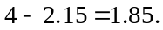
The answer is A.

Question 13

The number of people attending in the two months before May, in May itself and in the two months after May is 19, 20, 16, 12 and 18. The average of these five numbers is 17.
Note that the median of these five numbers is 18 but we were asked for the average and not the median.
The answer is D.

Section B

Module 1: Number patterns and applications

Question 1
The difference between each successive term of an arithmetic sequence is the same.
For option A, 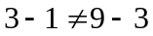
For option B, 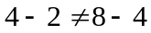
For option C, 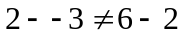
For option D, 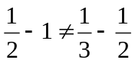
For option E, 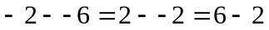, that is, the difference is the same and it is 4.
The answer is E.

Question 2
The difference between the third term and the fifth term is 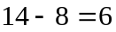. So the difference between the third term and the fourth term is 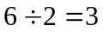. So the difference between successive terms is 3.
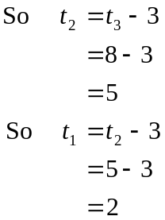
So the first term of the sequence is 2.
The answer is C.

Question 3
The sum of an infinite geometric sequence where 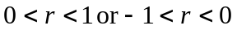 is given by
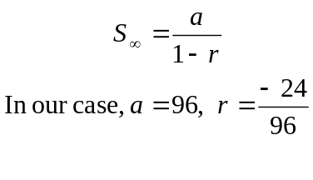
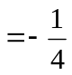
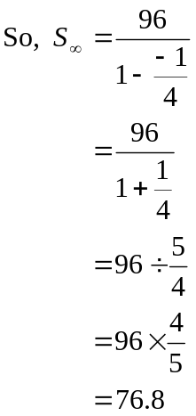
The answer is D.
Question 4
Since 35% of the cereal is dried fruit, then 65% of the cereal must be other ingredients. So the ratio of dried fruit to other ingredients is
35:65
which simplifies to
7:13 (by dividing both numbers by 5)
The answer is A.

Question 5
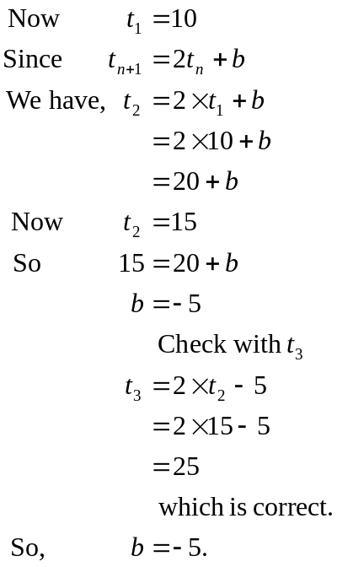
The answer is B.

Question 6
The sequence generated by the difference equation
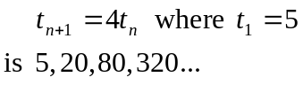
So, 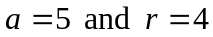.
The corresponding geometric sequence has the rule
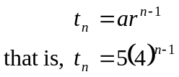
The answer is E.

Question 7
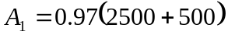 since at the start of the first year, George invests $2500. He adds $500 during the year. This amount of 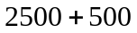decreases by 3% to become 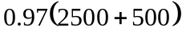 at the end of the year.
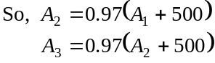
In general,
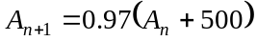
The answer is C.
Question 8
The ratio of old paint to new paint
is 2:10
or 1:5
There are a total of 6 parts, and 1 of these represents the pink paint. So, if we divide the required 4 litres by 6, we obtain 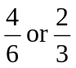. So litre of the total of 4 litres should be pink paint.
The answer is D.

Question 9
The number of cars produced, by the company in the 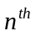 year forms a geometric sequence with 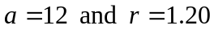.
We want to know when the sum of the cars produced by the company equals 100.

Method 1
In the 1st year 12 cars were produced.
In the 2nd year 14.4 cars were produced.
In the 3rd year 17.28 cars were produced.
In the 4th year 20.736 cars were produced.
In the 5th year 24.8832 cars were produced.
At the end of the 5th year a total of cars had been produced. In the 6th year, 29.86 cars had been produced. In total at the end of the 6th year there had been 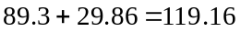cars produced.
So, during the sixth year of production, the 100th solar powered car was produced.
The answer is B.

Method 2
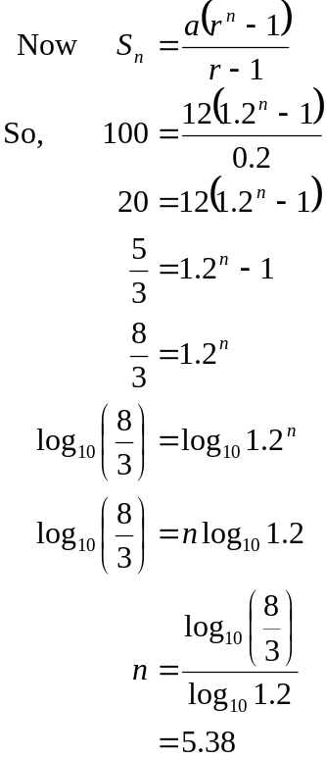
So during the 6th year of production, the 100th solar powered car was produced.
The answer is B.

Module 2: Geometry and trigonometry

Question 1
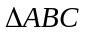 is a right-angled triangle.
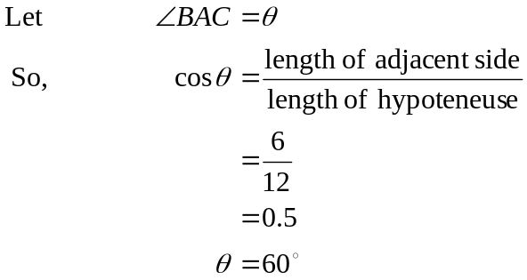
The answer is E.
Question 2
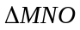 is a right-angled triangle.
So, using Pythagoras’ Theorem,
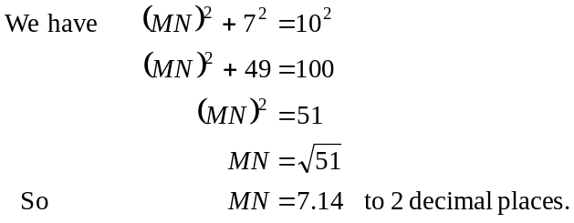
So the closest answer is 7cm.
The answer is C.

Question 3

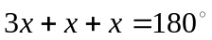 because 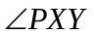 and 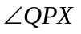 are cointerior angles.
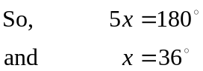
Also, 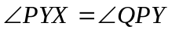 (alternate angles in parallel lines are equal).
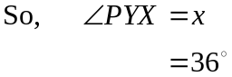
The answer is B.

Question 4
From the formula sheet we have 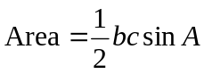
In our case, 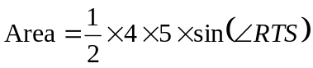
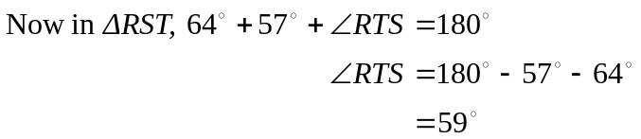
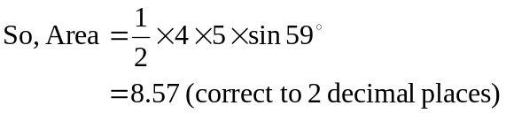
The answer is B.
Question 5
We know that
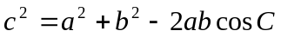
In our case
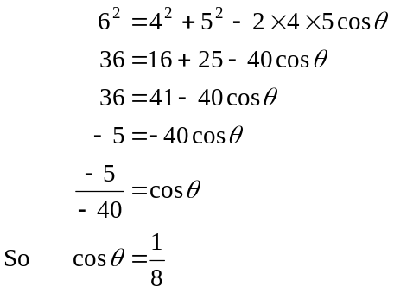
The answer is C.

Question 6
Consider firstly just the right pyramid.
In the diagram,  is a right-angled triangle and so
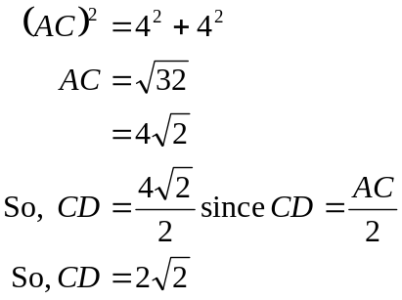
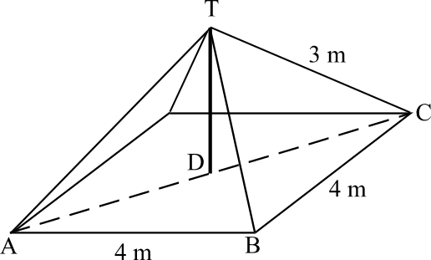
In 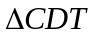, which is also a right angle,
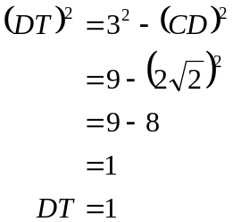
So the height of the pole is 1 metre, which is the height of the right pyramid plus 4 metres, which is the height of the cube base.
In total the height is 5m.
The answer is B.

Question 7

The lengths of the sides of the smaller triangle CDE compared to the larger triangle ABD are in the ratios 4:9. That is, the sidelengths of the larger triangle are 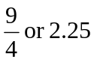 times that of the corresponding sidelengths of the smaller triangle. So, the area of the larger triangle will be 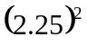 times the area of the smaller triangle.
That is, the area of 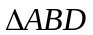 is
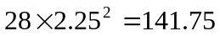
The answer is D.
Question 8
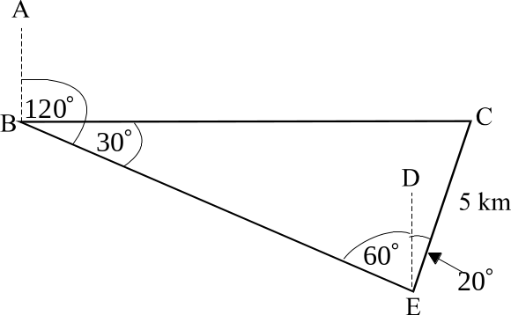

In the diagram, AB and DE each
run in a north-south line.
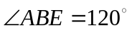
and so 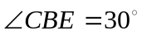
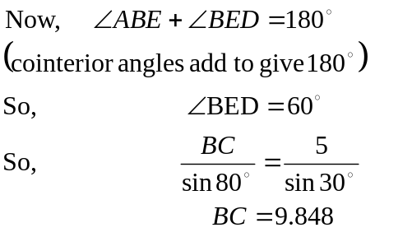
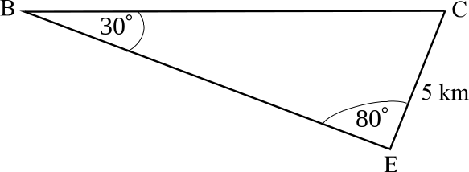
(to 3 dec. places)
So, the closest answer is C.

Question 9
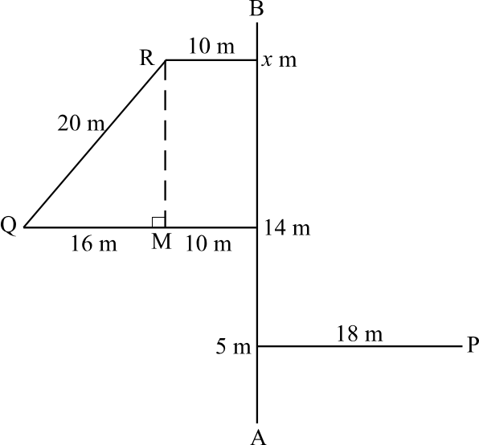

Drop a vertical line from R to the horizontal line which leads to feature Q.
Let the point of intersection be M.
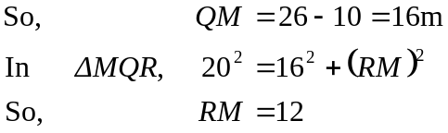
So 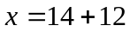 that is, the feature Q is 14m from point A measured along the base line and 12 metres further along the base line, feature R is located. So 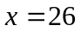.
The answer is D.

Module 3: Graphs and relations

Question 1

During the first minute of monitoring and then between the 8th minute and the 13th minute, the temperature was less than 80 degrees Celsius. So the total is 6 minutes.
The answer is B.

Question 2

The x-intercept occurs when y = 0
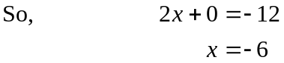
The y-intercept occurs when x = 0
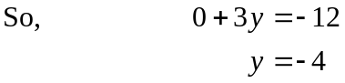
The graph passes through 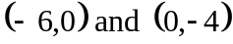.
The answer is A.

Question 3

Option A is correct since the steepest upward slope occurs between 1.45 and 2pm.
Option B is correct since the highest point on the graph occurs when 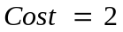.
Option C is correct since the stock started at $1.60 and finished at $1.80.
Option D is incorrect since the steepest downward slope occurred between 1pm and 1.45pm.
Option E is correct since the lowest point on the graph occurs when 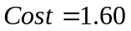.
The answer is D.

Question 4

Method 1
The line with equation 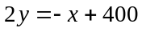 has an x-intercept of 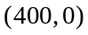. That is, when 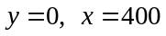. It has a y-intercept of 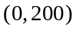. That is, when 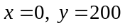. Only line 5 has the correct intercepts.

Method 2
The equation 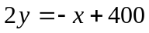 can be rearranged to become 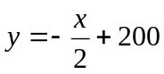
So the gradient of the line is  and the y-intercept is 200.
Lines 1 and 5 have a y-intercept of 200. The gradient however of line 1 is positive (that is, sloping up to the right) and so it cannot be the correct line.
The gradient of line 5 is given by 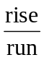.

Between points A and E, the rise is –200 (that is, the line is going down) and the run is 400.
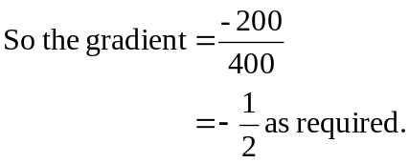
The answer is E.

Question 5

Point A is the point 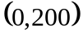
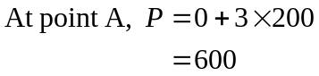
Point B is the point 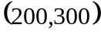
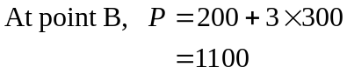
Point C is the point 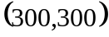
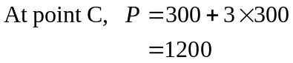
Point D is the point 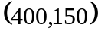
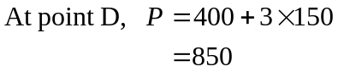
Point E is the point 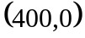
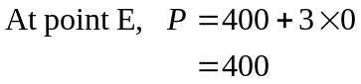
The maximum value of P occurs at point C.
The answer is C.

Question 6

The first customer bought 150 document wallets. The cost per wallet for more than 100 wallets and less than or equal to 200 wallets is $2.75. So the first customer spent 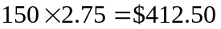.
The second customer bought 300 wallets. For more than 200 wallets but less than or equal to 300 wallets the cost per wallet is $2.50. So the second customer spent 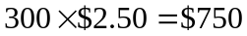.
The third customer bought 600 wallets. For more than 500 wallets, the cost per wallet is $2. So the third customer spent 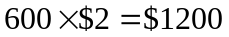.
The three customers spent in total .
The answer is D.

Question 7

The graph relating n and C for Package 1 is of the form 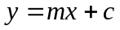 where c is the intercept on the vertical axis and m is the gradient. So for Package 1 the intercept on the vertical axis is 100. To find the gradient choose a section of the graph, say between 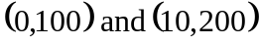. Over this section,
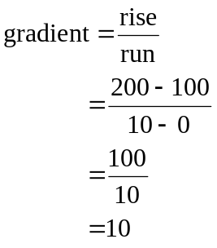
So the equation is 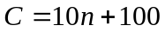. (Note that in our case the variable on the horizontal axis is n rather than x and the variable on the vertical axis is C rather than y.)
The answer is B.

Question 8

The lines representing Package 1 and Package 2 intersect at the point 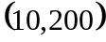. This means that for both packages, when there are 10 people attending lunch, the cost of the package is $200. So the difference between the two packages is $0.
The answer is A.

Question 9

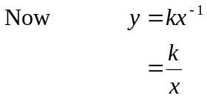
Since 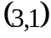 lies on this graph
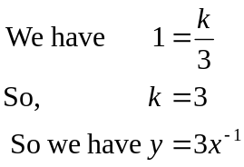
So, on the graph of 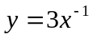, the point 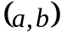 could be 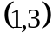 since if 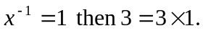
The other answers don’t satisfy this relationship.
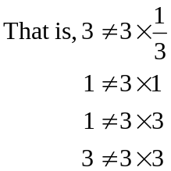
The answer is C.

Module 4: Business-related mathematics

Question 1

The formula for simple interest is 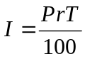.
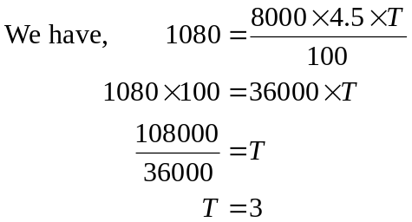
Paul had the money invested for 3 years.
The answer is C.

Question 2

Now the compound interest formula is
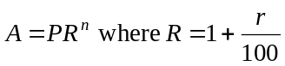
We have, 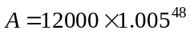 since
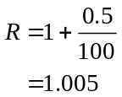
Note that the annual interest rate is 6%. Therefore the interest rate per month or per period is 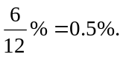
Also, the investment is for 4 years and during those 4 years there are 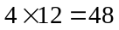 periods, that is, 48 times when interest is calculated.
Now, 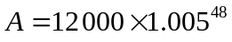
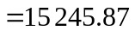
The answer is D.

Question 3

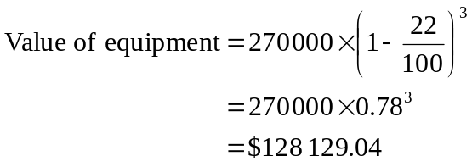
The answer is A.

Question 4
We don’t know the minimum balance in the month of April since we don’t know what happened before April 7 so we shall work with the May figures.
The minimum balance for the account during May is $1000. Interest for the month of May is $2.
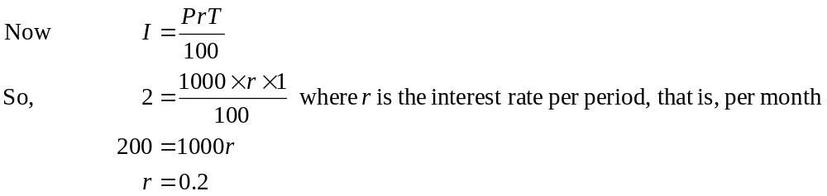
So the monthly interest rate is 0.2%. Therefore the annual interest rate is 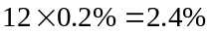.
The answer is E.

Question 5

Now, 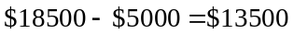. So, the machine has to depreciate by $13500 before it is traded. Now 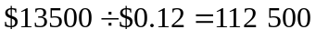
So, there are 112 500 lots of 12 cents in $13500. That is, a total of 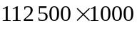copies can be done before the machine is traded. This amounts to 112 500 000 copies.
The answer is D.

Question 6

The annuities formula is given by
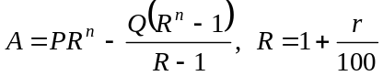
Now, in Brian’s case, 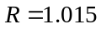
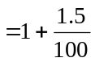
The annual rate of compound interest is 6%. The rate per period is 1.5%. So, the period is a quarter since 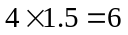. Another way to discover this is to look at the power, which R is raised to. It is 16. So, after 4 years, there are 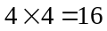 periods. So Brian, in line with interest being calculated quarterly, makes repayments quarterly.
The answer is C.

Question 7

An increase of 5.8% per year represents growth at an increasing amount each year.
Option A shows growth by the same amount each year.
Option C shows growth at a decreasing amount each year.
Option D shows decay at a decreasing amount per year.
Option E shows growth by the same amount each year starting at zero.
Option B is correct.
The answer is B.

Question 8

Use systematic trial and error.
The equation given is
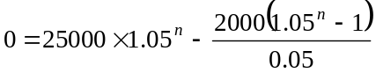
Let n = 10. Right side of equation = 15566.58
So, there is still money owing.
Let n = 20. Right side of equation = 200.53
Only $200 is owing so we are close.
If we go back by 1 year, there will be $4000 less in repayments. If we go forward by 1 year there will be an extra $4000 in repayments. So the closest answer to have $0 owing on the loan is 20 years.
The answer is D.

Question 9

Using the compound interest formula, we have
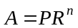
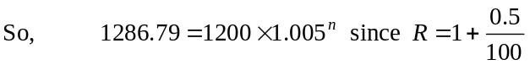
Where the period is 1 week and annual interest is 26%, so weekly interest is 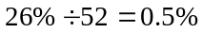

Method 1
Trial and error.
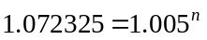
Try 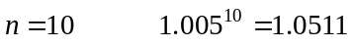
Try 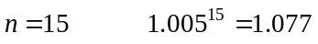
Try 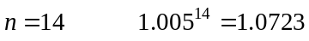
So James was 14 weeks late.
The answer is D.

Method 2
Using logs.
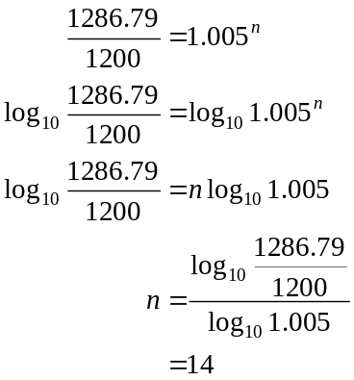
The answer is D.

Module 5: Networks and decision mathematics

Question 1

A complete graph has edges connecting all pairs of vertices. It is not a complete graph.
A degenerate graph has vertices but no edges. It is not a degenerate graph.
A simple graph has no loops or multiple edges. It is a simple graph.
A directed graph or digraph has a direction indicated on each of its edges.
A connected graph has no isolated vertices (like B). It is not a connected graph.
The answer is C.

Question 2

The degree of a vertex is the number of edges, which meet at it. The various vertices and their degrees are given in the table.

M | N | 0 | P | Q | R | S | T | U
2 | 3 | 3 | 2 | 2 | 5 | 3 | 5 | 3
The number with an even degree is 3.
The answer is C.

Question 3

A planar graph is a graph that can be drawn so that no edges intersect except of course at a vertex.
Options A and B have no intersecting edges and hence are planar.
Option C can be redrawn.
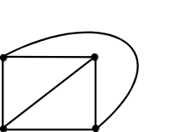

Option D can be redrawn.
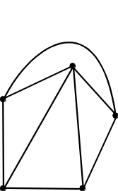

Option E cannot be redrawn so that no edges intersect.
The answer is E.

Question 4

Euler’s formula states that
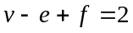
Euler’s formula is true for any connected planar graph.
For option A 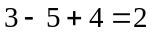
For option B 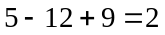
For option C 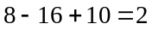
For option D 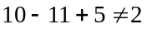
For option E 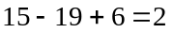
The answer is D.

Question 5

The number of edges joining each of the vertices has to be counted.
For example the number of edges joining W and Z is 2.
So in the matrix the entry for row W and column Z should be 2. Similarly the entry for row Z and column W should be 2. Only 1 of the vertices, X has an edge which connects itself to itself.
The answer is B.

Question 6

Immediately eliminate options D and E since activities A, B and C have no predecessors. The predecessor of F is B so eliminate option C. The predecessors of activity I are D and E, so eliminate option B.
The answer is A.

Question 7

The “ability” matrix is

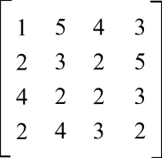

Using the Hungarian algorithm, we proceed.
Subtract the minimum entry from each row.
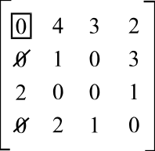

Select a row that has only one zero in it. Box it and cross out any zeros in the same column.
Repeat this process.

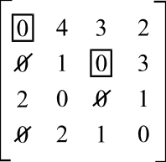

Repeat the process again.
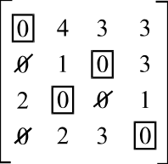

So, Bill should deal with printers. Spiro should deal with modems. Angela should deal with cd-writers and Jo should deal with monitors.
The answer is A.

Question 8
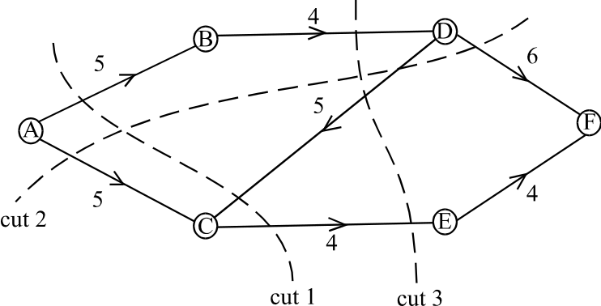

The capacity of cut 1 is 9. Note that since the flow from D to C runs in the opposite direction from that of A to F it is not counted.
The capacity of cut 2 is 11.
The capacity of cut 3 is 8.
The maximum flow equals the minimum cut. So the maximum flow is 8.
The answer is A.

Question 9
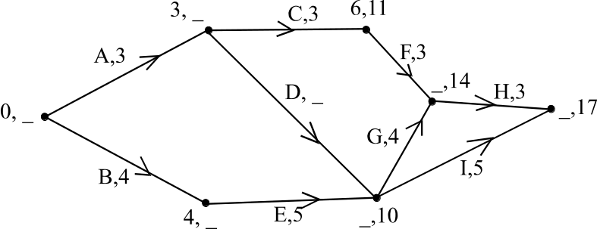

The earliest start time for each of the activities appears as the first number in the pair of numbers at each node. The latest start time for each of the activities appears as the second number in the pair of numbers at each mode. The time taken to complete the project is 17 weeks. Working backwards, we have the latest start time for activity H is 14 weeks and for activity G is 10 weeks.
Since activities A, D, G and H are on the critical path, their earliest start time must be equal to their latest start times.
So, the earliest start time for activity G is 10 weeks and since the earliest start time for activity D is 3 weeks, its duration must be 7 weeks.
The answer is E.

